SERRA ABABAY
A.Adnan Saygun Cad., Camlıtepe Sitesi,
C2, daire:1
Ulus/İstanbul
serraababay@gmail.com
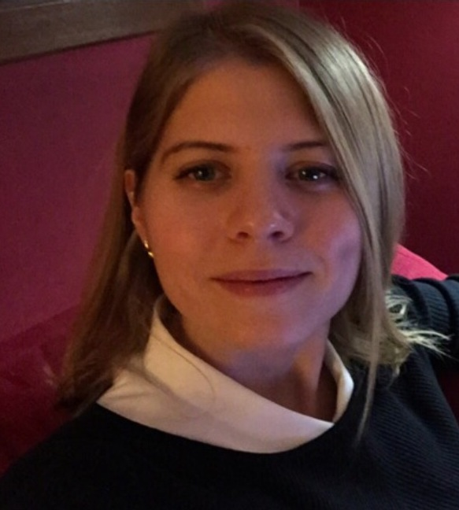
+90 537 456 74 10

EDUCATION
Istanbul Bilgi University, Clinical Psychology MA Program, Child and 2013-2016
Adolescent Track
GPA: 3.88 / 4.00
Dissertation title: What Happens When Fathers and Children Talk About Each Others’ Mental States in Play? : The Development of Social Representations and Affect Regulation Capacity

Related course work: Advanced Psychopathology I: Psychodynamic Models, Advanced Psychopathology II: Child/Adolescent DSM & Psychopharmacology, Child-Adolescent Psychological Assessment, Child Psychotherapy, Social Neuroscience, Child-Adolescent Psychotherapy Individual & Group Supervisions, Clinical Practicum

Koç University, College of Social Sciences and Humanities, Istanbul 2009-2013
Senior, Bachelor of Arts in Psychology, minor in Sociology.

Related course work: Developmental Psychology, Personality Psychology, Learning & Cognitive Psychology, Abnormal Psychology, Clinical Psychology, Industrial Psychology, Phsiology of Behavior, Conditioning Learning.
GPA: 3.83 / 4.00 Ranked 4th in the department.
Vehbi Koç Honours Award for 7 semesters.
The Koç School, İstanbul 2004-2009
Graduated with 4.53/5.00
Granted The Best French Award

College International de Cannes Summer School, France July 2007
Phillips Exeter Academy Summer School, USA June-July 2006

Harrow Summer School, England July 2005

Tasis American Summer School , Switzerland July 2003

EXPERIENCE

Istanbul University, Cerrahpaşa Faculty of Medicine, March 2016-present
Child and Adolescent Polyclinic
- Currently working as an adolescent clinical psychologist

Işıltı Psychological Counseling and Education Center January 2016-present
- Currently working as a child and adolescent clinical psychologist

Istanbul Bilgi University, Psychological Counseling Center 2014-present
- Works as a child and adolescent clinical psychologist

PSI Child and Family Psychological Counseling Center, Istanbul 2012-January 2016
- Worked as an assistant of Feriha Dildar, MA
- Assistant of PSY.572: Introduction to Special Education course offered
by Feriha Dildar at Istanbul Bilgi University
- Participated in weekly supervision sessions
- Provided at-home special education under supervision

Çapa Hospital, Istanbul July-2012
- Attended testing sessions in Testing Laboratory as an observer
- Received background information about tests and how to analyze the results
- Participated in weekly meetings hold by Expert Psychologist Hakan Kiziltan in which Psychodynamic perspective towards Nueroticism is emphasized

Memorial Hospital, Istanbul June-2012
- Intership in Clinical Psychology and Psychiatry Departments
- Active role in analysis of psychological test given to patients
- Literature review in adult psychology
PSI Child and Family Psychological Counseling Center, Istanbul October- April 2012
- Active role in weekly case discussions on variety of Childhood Disorders.
- Prepared case presentations related with disorders.

Atlıkarınca Kindergarten, Istanbul 2012
- Voluntary work in child education
- Works as an intern psychologist
Koç University Cognitive Lab, Istanbul 2011-2013
- Participated in the creation of items for the inventory on “Life Scripts”
- Interviewer at Reminiscence Bump Project
- Experience in content analysis

ACTIVITIES

Full Member of Turkish Infant Mental Health Association June 2015-present
(Member of World Association of Infant Mental Health)

Member of Turkish Child Infant Mental Health Association 2015-present
- Participates in the recstructuring the departments within the association
- Active role in representation of the association in the mass media
- Active role in the generation of seminar plans that would inform/educate
the mothers on parenting skills, around the rural areas of Turkey

Member of Turkish Psychological Association 2014-present

Member of Koç University Psychology Club 2009- 2013

SKILLS / CERTIFICATION/ COURSES

- Turkish Expressive and Receptive Language Test (TIFALDI) Examiner Certification
- Introduction to DIR (DIR 101) certification by ICDL (The Interdisciplinary Council on Development and Learning)
- Certified Coder of Child Play Therapy Instrument (CPTI )
- Certified Coder of Coding System for Mental State Talk in Narratives (CS-MST) by Steele, Steele and Bekar
- Mother-Infant Therapy Workshop by Susan Yabsley and Elizabeth Tuters from Hincks-Dellcrest
Institute
- Parent-Infant Psychotherapy Education by Inge Pretorious from Anna Freud Center
- Child and Adolescent in Clinical Setting Workshop by PSI Psychological Counseling Center

- Psychoanalytic Listening by Salman Akhtar , MD
- Working with Traumatized Youth: Diagnosis and Treatment by Dr.Sumru Bilge-Johnson, MD
- Infant Observation by Tavistock Clinic (Klinilk, İnci Vural) (Certification expected on September, 2017)

Child Assessment WISC-R, Denver II, Bender Gestalt II, C.A.T., T.A.T., TIFALDI, CBCL, Draw-a-Person, Draw-a-Family
Language English (advanced), IELTS 8.00
French (intermediate), Certificate in DELF B1 ( French )
Computer Excellent Microsoft Office Programmes, elementary level of SPSS,
proficient user of Qualtrics

